­­­

Intermolecular Forces and Gases

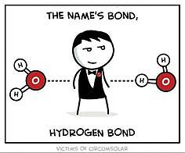

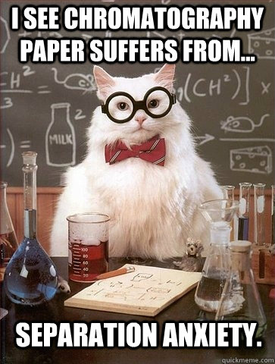 (Burgess n.d.)

(Admin, I See Chromatography Paper Cat Meme 2014) (Admin, Covalent Bond Cartoon Wallpapers 2015)

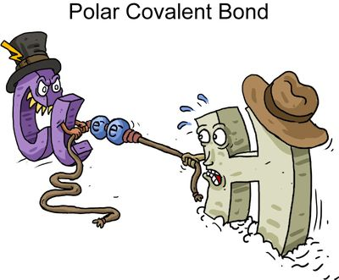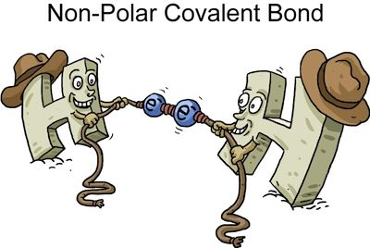

(Ramos n.d.)

|  |  |  |  |
| --- | --- | --- | --- |
| **Week** | **Outcomes** | **References + Tasks** | **Assessments** |
|  | * the valence shell electron pair repulsion (VSEPR) theory and Lewis structure diagrams can be used to explain, predict and draw the shapes of molecules * the polarity of molecules can be explained and predicted using knowledge of molecular shape, understanding of symmetry, and comparison of the electronegativity of atoms involved in the bond formation | Lucarelli Set 11 q 3  Lucarelli Set 12 q 5  Lucarelli Set 24 q1-8 | Task 11: Practical test- Post laboratory test 2  Task 12: Test- Intermolecular forces and gases  Task 13: Investigation- Chromatography to analyse intermolecular forces |
|  | * the shape and polarity of molecules can be used to explain and predict the nature and strength of intermolecular forces, including dispersion forces, dipole-dipole forces and hydrogen bonding * observable properties, including vapour pressure, melting point, boiling point and solubility, can be explained by considering the nature and strength of intermolecular forces within a covalent molecular substance | Lucarelli Set 25  q1-13, 15-16  STAWA Experiment 14  STAWA Experiment 15 |
|  | * data from chromatography techniques, including thin layer chromatography (TLC), gas chromatography (GC), and high-performance liquid chromatography (HPLC), can be used to determine the composition and purity of substances; the separation of the components is caused by the variation in strength of the interactions between atoms, molecules or ions in the mobile and stationary phases * the behaviour of an ideal gas, including the qualitative relationships between pressure, temperature and volume, can be explained using the Kinetic Theory * the mole concept can be used to calculate the mass of substances and volume of gases (at standard temperature and pressure) involved in a chemical reaction | Lucarelli Set 33 q 1-10  Lucarelli Set 1  q1-7, 10-13  Lucarelli Set 16 q 6-11  Lucarelli Set 18 q1-7 |

Resources

Davis, A. *Nelson Chemistry Units 1 & 2.* South Melbourne: Cengage Learning Australia Pty Limited, 2014.

Lucarelli, N. *ESSENTIAL CHEMISTRY Australian Curriculum for WA ATAR Chemistry Units 1 + 2.* Willetton: Lucas Publications, 2014

Clark, J and Baddock, M *Exploring Chemistry Year 11 Experiments, Investigations and Problems* Osborne Park STAWA, 2014.

### In addition the following objectives will need to be mastered in order to pass this course.

### Science Inquiry Skills

* identify, research, construct and refine questions for investigation; propose hypotheses; and predict possible outcomes
* design investigations, including the procedure(s) to be followed, the materials required, and the type and amount of primary and/or secondary data to be collected; conduct risk assessments; and consider research ethics
* conduct investigations safely, competently and methodically for the collection of valid and reliable data, including: chromatography, measuring pH, rate of reaction, identification of the products of reactions, and determination of solubilities of ionic compounds to recognise patterns in solubility
* represent data in meaningful and useful ways, including using appropriate graphic representations and correct units and symbols; organise and process data to identify trends, patterns and relationships; identify sources of random and systematic error; identify anomalous data; estimate the effect of error on measured results; and select, synthesise and use evidence to make and justify conclusions
* interpret a range of scientific and media texts, and evaluate processes, claims and conclusions by considering the quality of available evidence; and use reasoning to construct scientific arguments
* communicate to specific audiences and for specific purposes using appropriate language, nomenclature and formats, including scientific reports

Lewis Structures (Electron Dot Diagrams)

Lewis Structures: valence electrons in an atom, molecule or ion are shown as a dot or cross (a line can be used to represent a pair of electrons but this is usually reserved for molecules or polyatomic ions).

Examples:

Atoms hydrogen atom aluminium atom bromine atom

H Al Br

Monatomic Ions sodium ion strontium ion phosphide ion iodide ion

[Na]+ [Sr]2+ [ P ]3- [ I ]‒

Covalent molecules - atoms within a covalent molecule share electrons to achieve a noble gas configuration (in general this is eight electrons in the valence shell and so is called the octet rule). In sharing these electrons, the bonds formed can be single bonds (sharing two electrons), double bonds (sharing four electrons) or triple bonds (sharing six electrons).

chlorine carbon dioxide hydrogen cyanide

C*l* C*l* O C O H C N

C*l* C*l* O C O H C N

Polyatomic Ions - atoms within a polyatomic ion share electrons to achieve a noble gas configuration. Although polyatomic ions contain covalent bonds, they are still ions and, as such, are involved in ionic bonds.

hydroxide nitrate ammonium

‒

[ O H]‒ O N O H +

O N

H H H

Molecular Shapes

The shapes of covalent molecules are due to the repulsions between groups of valence electrons around the central atom. This is known as the valence shell electron pair repulsion (VSEPR) theory. The electrons (and hence, atoms) arrange themselves so as to minimise the repulsion between them.

When determining shapes, double and triple bonds are treated as though they are single bonds (in reality they have a slightly greater impact on repulsion between electron pairs and, as such, impact bond angles).

|  |  |  |  |  |
| --- | --- | --- | --- | --- |
| **Shape** | **Diagram** | **Number and types of valence electron groups** | **Bond Angle** | **Examples** |
| Linear |  | 1 or 2 groups of electrons | 180° | F2, CO2, etc |
| Bent (V-shaped) |  | 4 groups and two are lone pairs | ≈104.5° | H2O, SO2, etc |
| Triangular planar |  | 3 groups and none are lone pairs | 120° | CH2O, SO3, etc |
| Pyramidal |  | 4 groups and one is a lone pair | ≈107° | NH3, PC*l*3, etc |
| Tetrahedral |  | 4 groups and none are lone pairs | 109.5° | CH4, SiBr4, etc |

Example: Draw the Lewis structures of the following molecules and ions and name their shape.

CO, CS2, CH2C*l*2, H2S, PF3, O3, CO32-, SO42-, SO32-

**Electronegativity**

Electronegativity is an atom’s tendency to attract electrons.

Polar Bond

If two bonded atoms differ in electronegativities, the electron pair isn’t shared evenly within the covalent bond. The more electronegative atom attracts the electron(s) more strongly, creating an area of slightly negative charge (a negative pole) at that end of the bond, and a slightly positive pole at the other end. This is known as a bond dipole, polar moment or polar covalent bond. The greater the difference in the electronegativities of the two atoms, the greater the size of the dipole. Dipoles can be denoted a number of ways:

**δ+ δ‒**

Polar molecules

A molecule with multiple polar bonds may or may not be polar. It is dependent on the size and position of the polar bonds. A molecule will be polar if the vector sum (ie size and direction) of the individual bond dipoles gives an overall net dipole.

Example: For each of the following molecules draw in the polar bonds and determine if the molecule is polar or non-polar.

CO, CS2, CH4, CH3C*l*, CH2C*l*2, CHC*l*3, CC*l*4, H2S, PF3, O3

Intermolecular Forces (Van der Waals forces)

Intramolecular forces: the forces present within a molecule (i.e. covalent bonds). They are much stronger than intermolecular forces (as are ionic and metallic bonds).

Intermolecular forces: the forces present between molecules. They are much weaker than intramolecular forces and can be used to explain variations in melting and boiling points, vapour pressure and solubility. In general, the greater the strength of intermolecular forces, the higher the melting and boiling points and the lower the vapour pressure (solubility is a bit more complex).

* **Dispersion Forces –** occurs in all molecules but are most significant in non-polar molecules and monatomic gases. It is due to the random motion of shared valence electrons which are not symmetrically shared and so can produce a temporary dipole. This temporary dipole can then induce temporary dipoles in nearby molecules. These dipoles then experience weak electrostatic attractive forces called dispersion forces. As the induced dipoles are temporary, they are constantly appearing then disappearing and then reappearing somewhere else.

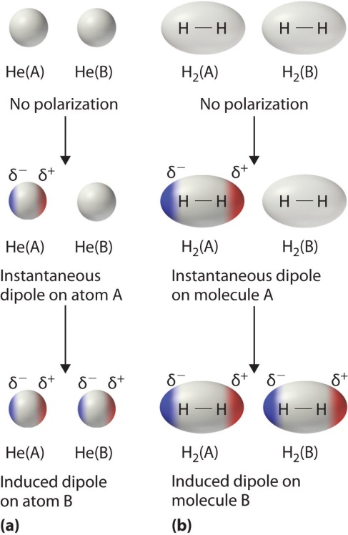

(Larsen n.d.)

Dispersion forces increase in strength with increasing number of electrons. This leads to an increase in melting and boiling points and a decrease in vapour pressure.

|  |  |  |
| --- | --- | --- |
| **Molecule** | **Melting Point (°C)** | **Boiling Point (°C)** |
| F2 | -220 | -188 |
| C*l*2 | -101 | -35 |
| Br2 | -7 | 59 |
| I2 | 114 | 184 |

Similarly, dispersion forces increase in strength for molecules of similar mass that have a greater surface contact between the molecules (i.e. linear molecules experience greater dispersion forces than branched or cyclical analogues).

|  |  |  |
| --- | --- | --- |
| **Molecule** | **Melting Point (°C)** | **Boiling Point (°C)** |
| Pentane | -130 | 36 |
| Methybutane | -160 | 28 |
| Dimethylpropane | -18 | 9.5 |

* **Dipole-Dipole Forces –** occurs in polar molecules. It is due to the electrostatic attraction between oppositely charged ends of the overall dipole.

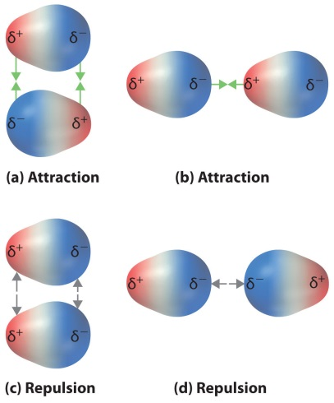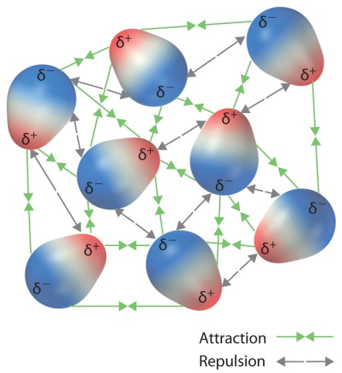

(Larsen n.d.)

The strength of a dipole moment increases with the increased difference in electronegativities between atoms in a molecule. Substances with polar molecules have slightly higher melting and boiling points than other substances of similar molecular size that have non-polar molecules.

Although the strength of a dipole moment increases with the increased difference in electronegativities between atoms in a molecule, the dispersion forces become more significant with increasing number of electrons (size of molecule). This adds to the intermolecular forces and increases the melting and boiling points.

|  |  |  |
| --- | --- | --- |
| **Molecule** | **Melting Point (°C)** | **Boiling Point (°C)** |
| CH3F | -138 | -79 |
| CH3C*l* | -97 | -24 |
| CH3Br | -93 | 3 |
| CH3I | -66 | 42 |

* **Hydrogen Bonding –** is an extreme form of dipole-dipole forces. It occurs when a hydrogen atom is bonded to a fluorine, oxygen or nitrogen atom in a molecule and it interacts with a non-bonding pair (lone pair) of electrons on another fluorine, oxygen or nitrogen atom in another molecul*e.*Hydrogen bonding is due to the highly electronegative nature of fluorine, oxygen and nitrogen that have a high charge density due to their relatively small size.

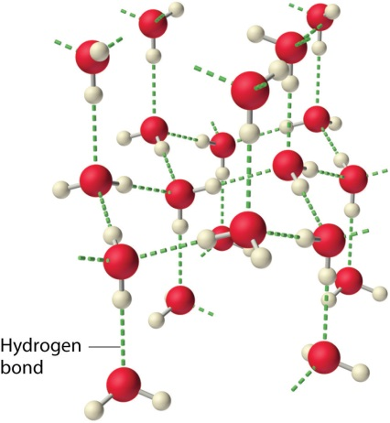

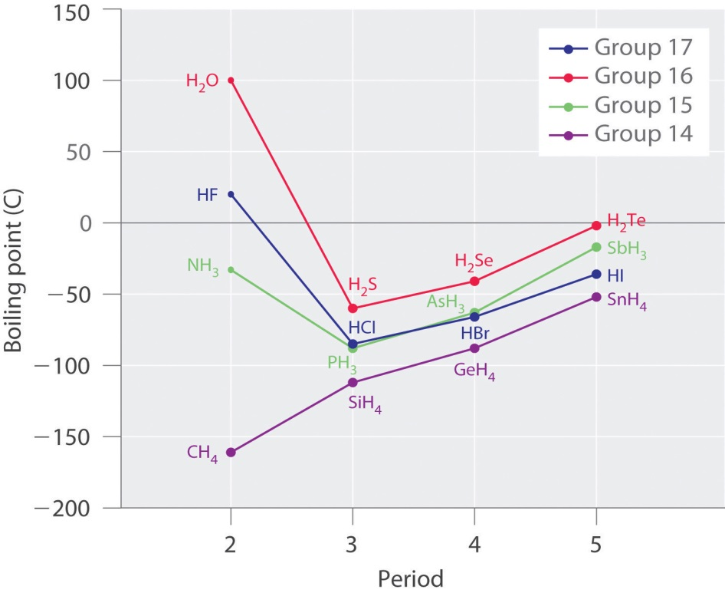

(Larsen n.d.)

(Larsen n.d.)

Alcohols and carboxylic acids are also capable of hydrogen bonding.

|  |  |  |  |  |  |  |
| --- | --- | --- | --- | --- | --- | --- |
| **Alcohols** | | | | | | |
| Methanol | | Ethanol | | Propan-1-ol | | Butan-1-ol |
| https://christophereppig.files.wordpress.com/2014/06/alcohols.jpg | | https://christophereppig.files.wordpress.com/2014/06/alcohols.jpg | | https://christophereppig.files.wordpress.com/2014/06/alcohols.jpg | |  |
|  | | | | | | |
| **Carboxylic acids** | | | | | | |
| Methanoic acid | Ethanoic acid | | Propanoic acid | | Butanoic acid | |
| Methanoic Acid | Ethanoic Acid | | Propanoic Acid | | Butanoic Acid | |

**Significance of water**

Boiling and melting points of hydrogen bonded substances tend to be much higher than those of substances of similar molecular size that display only dipole-dipole or dispersion forces.

Water has the highest melting point as its molecular arrangement allows each water molecule to form up to four hydrogen bonds whilst HF and NH3 typically form only two hydrogen bonds with other molecules. (refer to diagram on previous page)

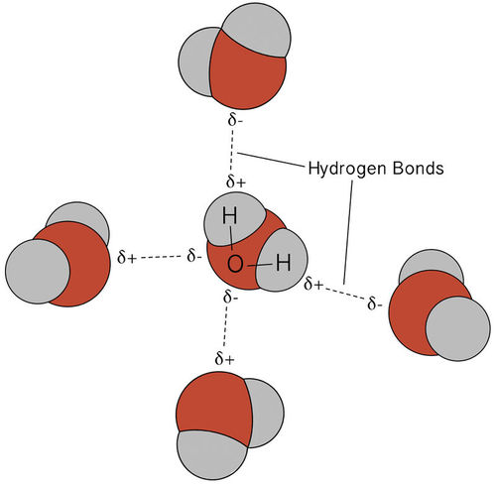

**Solubility**

A solute will be soluble in a solvent if the solute- solvent intermolecular forces are of similar strength (or stronger) to the solute- solute intermolecular forces and to the solvent-solvent intermolecular forces.

**Eg** Dissolving ethanol in water

**Solvent =** water : most significant solvent -solvent intermolecular force is hydrogen bonding.

**Solute =** ethanol : most significant solute- solute intermolecular force is hydrogen bonding.

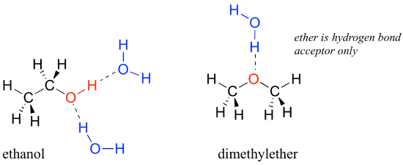The solute- solvent intermolecular force that can exist between ethanol and water is hydrogen bonding so ethanol will be soluble in water.

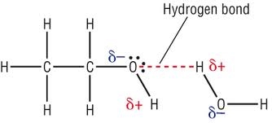

Chromatography – an analytical technique used to separate and identify components (or analytes) of mixtures. It can also be used to determine the concentration of these components in the mixture. The principles of the various types of chromatography are the same. That is:

* The mixture is placed into a mobile phase (this may be a liquid solvent or a gas stream)
* The mobile phase containing the mixture is passed over a stationary phase
* The different components in the mixture adsorb to the stationary phase at different points in time depending on the nature of the stationary phase and the analytes in the mixture.

There are a few different types of chromatography that can be used to identify the analytes (or components) in a mixture.

* **Thin Layer Chromatography (TLC)**
  + Used for organic mixtures such as plant pigments and drugs.
  + A thin glass plate is coated with finely powdered alumina, A*l*2O3 or silica SiO2 which acts as the stationary phase.
  + The mobile phase is a solvent that will dissolve and separate the components of the mixture.
  + The mobile phase moves up the stationary phase by capillary action.
  + The TLC plate and solvent are placed in a sealed container to ensure the vapour phase is saturated with gaseous solvent particles and to prevent the solvent evaporating.
  + Due to the difference in polarity of the analytes they are carried up the stationary phase at different rates and adsorb at different points.
  + The components in the mixture can be identified by their retardation factor, Rf where:

Rf = 

* + In TLC, the Rf of a given substance is not constant as it depends on the nature of the stationary and mobile phases. For this reason a TLC of the different pure substances thought to be present in the mixture needs to be produced under identical conditions in order to obtain comparable Rf values.
  + TLC has the advantage of being a relatively simple and inexpensive way of confirming the purity of a mixture.

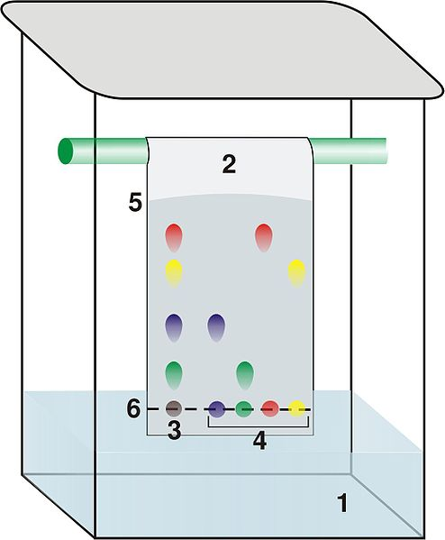

**1 - solvent**

**2 – TLC plate**

**3 – analyte**

**4 – pure components**

**5 – solvent front**

**6 – point of origin**

(Dubaj 2006)

* **Gas Chromatography (GC)**
  + Used to identify individual heat stable, relatively small molar mass analytes and their concentrations in complex mixtures.
  + Mobile phase is an inert carrier gas such as He or N2.
  + Stationary phase is a high boiling point non-volatile viscous liquid adsorbed onto solid particles such as silica. This is packed within a long stainless steel coiled column that may be 2-5 mm in diameter and 1.5 – 100 m in length.
  + The gas chromatograph consists of a gas supply, high temperature injection chamber, column, detector and recorder.
  + The liquid mixture to be analysed is injected through a rubber seal and vaporised.
  + The vaporised mixture then travels through the temperature controlled column. The analytes remain either in the mobile phase or stationary phase based on its volatility (tendency to evaporate). Analytes with a higher volatility tend to remain in the mobile phase. These exit (are eluted from) the column quickly and have a smaller retention time.
  + Analytes can be identified by producing a chromatogram of the pure analyte under the same conditions of column choice, carrier gas, gas flow rate and temperature.
  + Analyte concentrations can be determined from the height and area of a chromatogram peak when compared to the peaks produced from a set of standards.

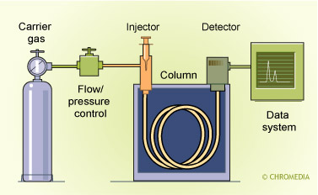

(Snow 2015)

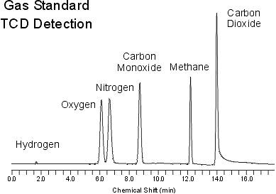

(Thet K n.d.)

* **High Performance Liquid Chromatography (HPLC)**
  + Used to identify individual, relatively large molar mass analytes which are unstable when heated and their concentrations in complex mixtures.
  + Mobile phase is a non-polar liquid solvent.
  + Stationary phase is made up fine particles such as SiO2 that are polar. This is packed within a short stainless steel coiled column that may be 3-5 mm in diameter and 10 – 30 cm in length.
  + In reverse phase HPLC the stationary phase is non-polar and the mobile phase is polar.
  + The high performance liquid chromatograph consists of a high pressure pump, sample injection loop, column, detector and recorder.
  + The liquid mixture to be analysed is injected through an injection loop into a high pressure column of solvent.
  + The sample then travels through the column. The analytes travel at different rates through the stationary phase based on their polarity. Analytes with a higher polarity tend to adsorb on to the stationary phase. These take longer to travel through the column and have a larger retention time.
  + Analytes can be identified by producing a chromatogram of the pure analyte under the same conditions of column choice, mobile solvent and solvent flow rate.
  + Analyte concentrations can be determined from the height and area of a chromatogram peak when compared to the peaks produced from a set of standards.

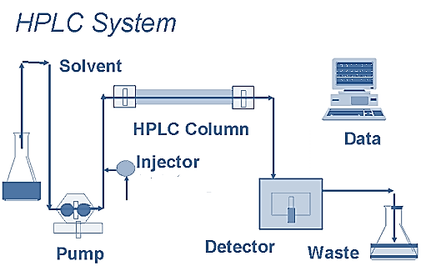

(Chhabra 2013)

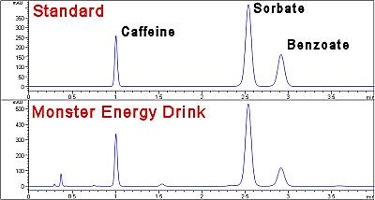

Time (min)

absorbance

(ACCTA Inc n.d.)

**Gases –** Much of the physical behaviour of gases can be explained using the kinetic theory of gases. This theory is based on the movement of the gas particles which is fundamental in determining the physical properties of gases. The current model is based on the ideal gas and states:

* Gases consist of molecules (or atoms in the case of noble gases) that move in continuous, rapid, random, straight-lined motion.
* The space between gas particles is so large that the volume of the particles themselves is negligible when compared to the volume the gas occupies.
* The forces of attraction and/or repulsion between gas particles are negligible.
* All collisions between gas particles are perfectly elastic (ie no net gain or loss of energy)
* The average kinetic energy (EK = ½mv2) of the gas particles is proportional to its temperature and is the same for all gases at the same temperature.

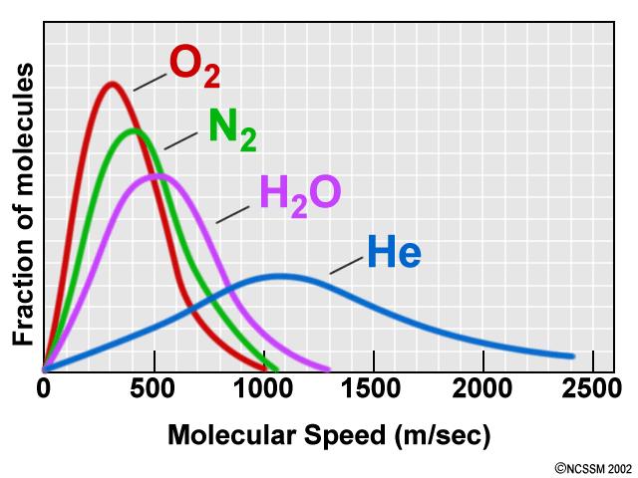With regards to this last point, this suggests that for different gases at the same temperature, as they possess different masses, the velocity of the particles differ.

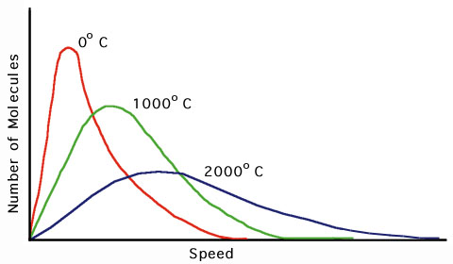 (North Carolina School of Science and Mathematics n.d.)

(Casiday R 2000)

**Absolute Zero**

As the temperature of the gas is decreased, the velocity of the particles also decreases. Theoretically, at low enough temperatures, the particles will cease moving. This lowest theoretical temperature is called absolute zero and is equal to ‒273.15 °C or 0 K (Kelvin). To convert K→°C minus 273.15, to convert °C→K add 273.15

**The kinetic theory of gases can explain physical properties of gases including:**

* Gases diffuse – due to their rapid, random, straight-lined motion and have negligible forces of attraction or repulsion between them.
* Gases are compressible – due to the very large space between them and the particles possessing negligible volume themselves.
* Gases take the shape of the container they are in – due to their rapid, random, straight-lined motion and have negligible forces of attraction or repulsion between them.
* Gases exert pressure – due to their motion, they collide with the container walls (pressure increases with increasing force and frequency of these collisions).
* Gases have a low density – due to the very large spaces between the particles.

Ideal vs real gases

It is important to note that the kinetic theory of gases is based on the notion of an ideal gas. In reality real gases differ from an ideal gas in that real gases:

* Exert forces of attraction and repulsion
* Occupy volume which can be significant when compared to the volume of the gas as a whole

Real gases approach ideal gases under the conditions of high temperature and low pressure.

The nature of gases lends itself to describing a relationship between three properties of a gas; pressure, temperature and volume.

Charles Law

* At constant pressure, the volume of a fixed quantity of gas is directly proportional to its temperature (ie V T). This is known as Charles’ law.

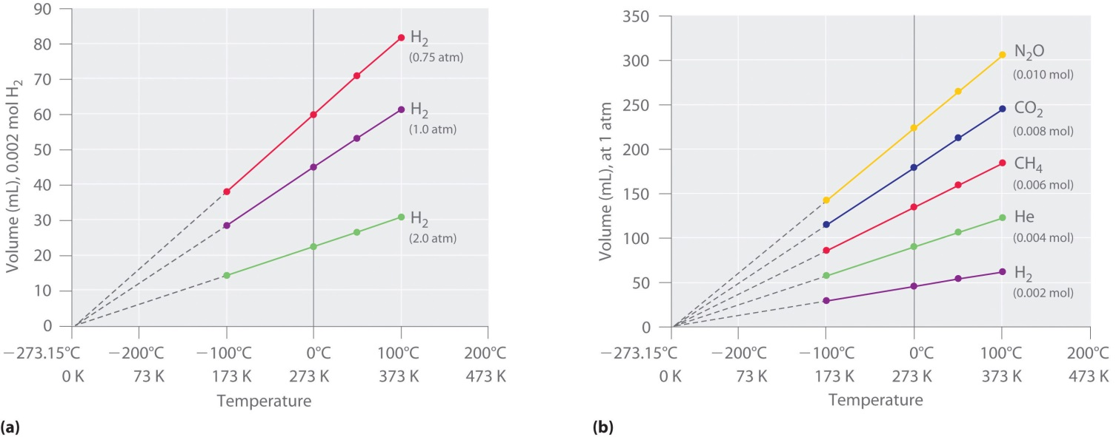

(Schmitz 2012)

Notice that a plot of any gas’ volume as a function of temperature, if extrapolated will intercept the X-axis at absolute zero.

Charles’ law can be explained using kinetic theory. In a fixed quantity of gas, if you increase the temperature, the pressure will increase because the gas particles gain kinetic energy and begin moving faster, hitting the container walls more often. In order to maintain a constant pressure, the volume must be increased so that the gas particles have further to travel before hitting the container walls.

**Boyles Law**

* At constant temperature, the volume of a fixed quantity of gas is inversely proportional to its pressure (ie V ). This is known as Boyle’s law.

Explain Boyle’s law in terms of kinetic theory.

In a fixed quantity of gas at constant temperature, if you increase the volume, the pressure will decrease because the gas particles have further to travel before hitting the container walls. The opposite is true if you decrease the volume.

In a fixed quantity of gas at constant temperature, if you decrease the volume, the pressure will increase. This is because the particles of the gas are pushed closer together and hit the walls of the container more often.

**Pressure and temperature at constant volume**:

At constant volume, the pressure of a fixed quantity of gas is directly proportional to its temperature.

Explain the relationship in terms of the kinetic theory. In a fixed quantity of gas at constant volume, if you increase the temperature, the pressure will increase because the gas particles gain kinetic energy and begin moving faster and they will hit the walls of the container more often.

**Avogadro’s hypothesis**

The previous relationships between gas pressure and volume and temperature have assumed a fixed amount of gas and, therefore, the number of particles or moles of gas. This suggests that if the pressure and temperature are kept constant then the number of moles of gas is directly proportional to volume. This is true of all gases because volume is dependent on number of particles, not type of particles.

**So: the same number of moles of any gas at the same temperature and pressure will have the same volume.**

This fact is reflected in Avogadro’s hypothesis which states that equal volumes of any gas, measured at the same temperature and pressure, contain equal number of particles. Furthermore, the molar volume of a gas under standard temperature and pressure conditions (ie 273.15 K (or 0 °C) and 100.0 kPa) equals 22.71 L. That is;



Where n = number of moles (n) and V = volume (L).

**1 mole of any gas at STP will have a volume of 22.71 L**

# Bibliography

ACCTA Inc. "Caffeine, Sorbate and Benzate by HPLC." *ACCTA.* n.d. http://www.accta.com/Methods/sorbate.html (accessed August 2, 2015).

Admin. "Covalent Bond Cartoon Wallpapers." *Mass Wallpapers.* 2015. http://masswallpapers.mobi/2015/07/covalent-bond-cartoon-wallpapers/ (accessed July 31, 2015).

—. "I See Chromatography Paper Cat Meme." *Cat Planet.* 2014. http://catplanet.org/i-see-chromatography-paper-cat-meme/ (accessed August 2, 2015).

Burgess, H. "Chemistry - Covalent Bonding and Water." *Pintrest.* n.d. https://www.pinterest.com/heathergratzer/chemistry-covalent-bonding-water/ (accessed July 29, 2015).

Casiday R, Frey R. "Gas Laws Save Lives: The Chemistry Behind Air Bags." *Washington University in St Louis.* October 2000. http://www.chemistry.wustl.edu/~edudev/LabTutorials/Airbags/airbags.html (accessed August 2, 2015).

Chhabra, N. "High Performance Liquid Chromatography." *Biochemistry for Biomedics.* April 15, 2013. http://www.namrata.co/chromatography-2/high-performance-liquid-chromatography/ (accessed August 2, 2015).

Dubaj. "Structural Biochemistry/Chromatography/Thin Layer." *Wikibooks.* April 29, 2006. https://en.wikibooks.org/wiki/Structural_Biochemistry/Chromatography/Thin_Layer (accessed August 1, 2015).

Larsen, D. "11.2 Intermolecular Forces." *UCDavis Chemwiki.* n.d. http://chemwiki.ucdavis.edu/Wikitexts/UC_Davis/UCD_Chem_2B/UCD_Chem_2B%3A_Larsen/Unit_II%3A_States_of_Matter/Intermolecular_Interactions/11.2%3A_Intermolecular_Forces (accessed August 1, 2015).

North Carolina School of Science and Mathematics. "Gases." *Teachers' Instructional Graphics Educational Resource.* n.d. http://www.dlt.ncssm.edu/tiger/chem3.htm (accessed August 2, 2015).

Ramos, E. "Funny Pictures About Types of Bonds." *Pintrest.* n.d. https://www.pinterest.com/pin/361202832589039573/ (accessed August 2, 2015).

Schmitz, A. "Relationships Among Pressure, Temperature, Volume and Amount." *2012 Book Archive.* December 29, 2012. http://2012books.lardbucket.org/books/principles-of-general-chemistry-v1.0/s14-03-relationships-among-pressure-t.html (accessed August 2, 2015).

Snow, N. "Introduction to Capillary GC injection Technique." *Chromedia Analytical Sciences.* 2015. http://www.chromedia.org/chromedia?waxtrapp=wlqdcDsHqnOxmOlIEcClBwFjE&subNav=rwhpbjDsHqnOxmOlIEcClBwFjEQ (accessed August 1, 2015).

Thet K, Woo N. "Gas Chromatography." *UCDavis Chemwiki.* n.d. http://chemwiki.ucdavis.edu/Analytical_Chemistry/Instrumental_Analysis/Chromatography/Gas_Chromatography (accessed August 2015, 2015).